HuffPost News Category Classification

Jenny James, Sergey Nelyapanko, & Lexi Fortuna
DX703-O1 (Spring 2026) - Advanced Machine Learning and AI
Faculty of Computing & Data Sciences, Boston University
Professor Wayne Snyder
April 26, 2026

B.1 Introduction and Problem Definition
B.1.1 Problem Description and Motivation
We are in the heart of the digital age and online news continues to be on the rise and the way most people get their daily news. This has generated a need for an efficient and accurate system to be able to categorize news articles. With that system being in place, improvements to online search results and recommendations can be put in place, which in-turn improves user experience because they can easily find what they are looking for. News platforms post hundreds, if not thousands of articles everyday covering just about any topic you can think of. This contributes to manual categorization no longer being feasible due to time-constraints and possible inconsistencies.
B.1.2 Project Goals in Both Business and Data-Science Terms
In the business realm, this project supports the need of increasing user engagement and retention. By automating article categorization at scale, this allows for a reliable and accurate system to handle thousands of articles per day. The quicker users find the articles they are looking for, increases the likelihood of more time spent on the platform which means more of a chance the user is looking through the more accurate recommended articles.
In data science terms, this project is predicting the category a news article belongs to from a predefined list of categories. A constraint of this prediction model is that article headlines and descriptions sometimes only provide short text inputs which gives the model very limited context. Another constraint that should be considered is the balance of the training dataset, that can make or break the model when scaling up for real-world use.

B.1.3 Dataset Description
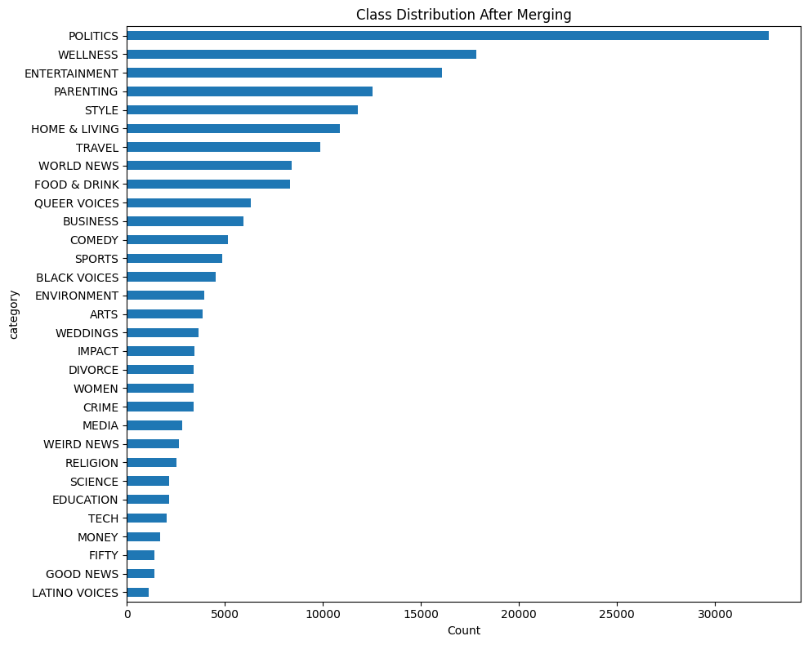
The dataset used in this model analysis is the HuffPost News Category Dataset, obtained from Hugging Face. This dataset consists of news articles published by HuffPost between the years of 2012 and 2018. The raw dataset contains 200,853 records, 41 unique features, and six attributes: Category, Headline, Authors, Link to the Article, Short Description, and Date. After exploratory data analysis was performed, the dataset was found to have substantial overlap among several categories. To address this several categories were merged and resulted in a reduced set of 31 distinct classes. The class distribution is visualized in Figure 1. The largest category, Politics, contains 32,721 articles while the smallest category, Latino Voices, contains only 1,129 articles. This displays a severe class imbalance, but the median class size was found to be lower than the mean which is indication of long-tailed distribution with a lot of underrepresented categories. For more information on the exploratory data analysis (EDA), please see Appendix A.
Figure 1. Class distribution following EDA
B.2 Methodology
B.2.1 Preprocessing Pipeline
Prior to the building of the final model, each sample’s text was formed by concatenating the headline and short_description with a [SEP] separator. When the description was missing (9.98% of records), the headline alone was used. A TextVectorization layer was configured with max_tokens=20,000 and output_sequence_length=64. This was chosen based on the computed P95 word count of 57 words. The layer was adapted on training text only, then applied once to produce integer-encoded numpy arrays (shape 160,290 x 64), avoiding repeated tokenization during training. No text augmentation was applied at this stage. The Hugging Face AutoTokenizer for DistilBERT was utilized with padding and truncation. Class weights were computed using sklearn.compute_class_weight(“balanced”) which produced weights from 0.198 (Politics) to 5.726 (Latino Voices) further supporting the evidence of severe class imbalance.
B.2.2 Model Architecture and Justification
The model that performed the best was DistilBERT (distilbert-base-uncased). This is a distilled version of BERT that retains 97% of BERT’s language understanding while being 40% faster and 60% faster. When experimenting with other BERT models, such as BERT and RoBERTa, they were found to be too heavy for the available computing budget and the short-text classification task the model is accomplishing. What makes DistilBERT a practical choice for this dataset is that it stabilizes faster and does not need as many epochs to reach an acceptable validation performance. Since DistilBERT is a pretrained model, only 2 adaptations were made. Since this is a Hugging Face dataset, TFDistilBertForSequenceClassification class with num_labels=31 was used and the masked language model head was replaced with the following classification head: Pre-classifier(786, 786) + Classifier(786, 31).
B.2.3 Training Strategy
Table 1 below covers all specific training configurations used on the DistilBERT model. Since the task at hand is not one requiring deep syntactic reasoning, the embedding layer and the bottom 4 transformer blocks were frozen and the top 2 transformer blocks were unfrozen for fine-tuning. This yielded 36 trainable variable tensors. This approach was chosen because the lower layers capture grammatical features which are less relevant for our approach, the upper layers capture topical features which are directly relevant to the task at hand, and a small learning rate with cosine decay ensures gentle adaptation for the unfrozen layers. A smaller learning rate was also applied so it can gently adapt to the features.
Table 1. DistilBERT Specific Training Configurations
Optimizer | Learning Rate | Max Epochs | Batch Size | Early Stopping | Loss | Class Weights
AdamW  (Weight Decay) | 2e-5  (cosine schedule) | 16 | 128 | Yes  (patience=2) | Sparse Categorical Crossentropy | Yes

B.2.4 Performance Validation
The DistilBERT model was trained using a 50% stratified subset (80,145 samples) to manage computation time within the available budget. For DistilBERT class weight was set to balanced and full fine-tuning was ruled out as it tends to overfit dominant classes and cause unstable training. To avoid data leakage in the DistilBERT model, overlapping categories were merged, empty headlines were dropped, and exact duplicates were also dropped prior to building the training/validation split.
B.3 Results and Evaluation
B.3.1 Quantitative Results
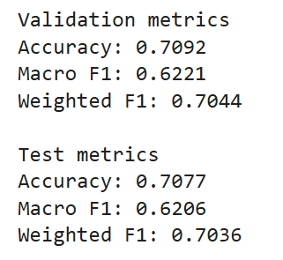
Figure 2 displays the overall model’s validation and test metrics. The model displayed near identical performance between the validation and test sets. Figure 3 displays the training and validation loss curves and Figure 4 displays the confusion matrix for test predictions.
Figure 2. DistilBERT validation and test metrics
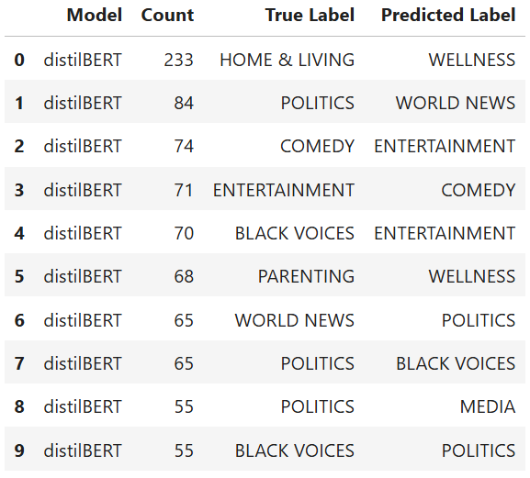
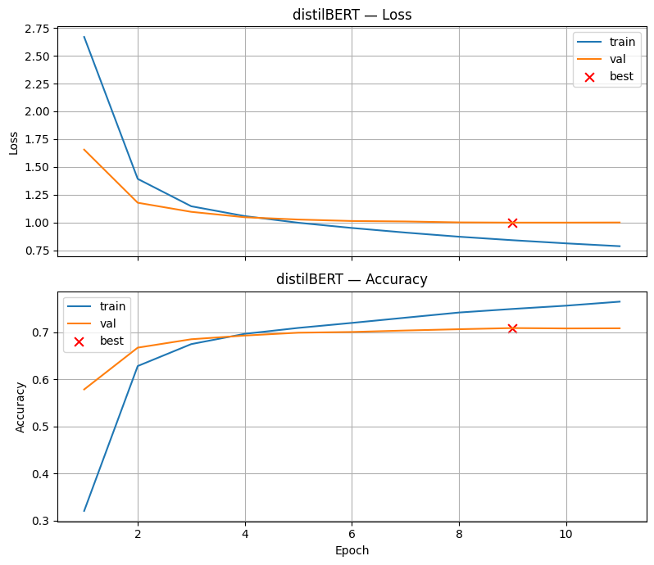
Figure 4. DistilBERT’s confusion matrix for test predictions
Figure 3. DistilBERT training and validation loss curves
B.3.2 Interpretation of Results
Based on Figure 2, DistilBERT demonstrates stable generalization because of the nearly identical test and validation accuracy metrics. The weighted-F1 score and accuracy are similar which points to a strong performance for majority classes, but the lower macro-F1 score suggests that the minority classes are struggling due to the severe class imbalance. From Figure 3, the curves indicate effective convergence. Although the validation loss plateaus starting at epoch 9 and training loss continues to decline slightly. This can suggest stable learning but need to be conscious of overfitting. Figure 4 displays the confusion matrix which points to there still being some semantically similar categories: POLITICS vs. WORLD NEWS, COMEDY vs. ENTERTAINMENT, and PARENTING vs. WELLNESS. This also displays the class imbalance of the dataset because the underrepresented categories (BLACK VOICES) are also included. For class by class evaluation metrics please see Appendix B.
B.3.3 Summary of Final Model Performance
DistilBERT is a pre-trained transformer which makes it one of the better models for this classification task. This is driven though the leveraging of the pretrained contextual embedding and selective fine-tuning of the semantic layers. These things allow DistilBERT to better capture nuances within the headlines and short descriptions of the articles when comparing to simpler models perfomring the same task. From the above results above, a strength that was expected and displayed was the performance in the sense that no class received zero predictions and the F1 score improved across the board. In conjunction, the weakness that was displayed was the model still struggling to predict semantically similar categories even after the merging of the confusing categories. DistilBERT is a much heavier model in comparison to other methods tried which comes at a high computational cost (67 million parameters and increased training time per epoch). This high computational cost was deemed necessary because of the end performance of the model based on the task at hand.
B.4 Discussion and Reflection
B.4.1 Limitations and Sources of Error
Five different limitations and sources of error were identified. The first being the dataset ambiguity. The most persistent errors (HOME & LIVING ↔ WELLNESS, ENTERTAINMENT ↔ COMEDY, POLITICS ↔ WORLD NEWS reflect genuine semantic overlap in the HuffPost editorial taxonomy rather than a model failure. DistilBERT provides rich contextual representations and could not fully resolve these confusions because the categories themselves are not cleanly separable from short text alone. The second is the short text constraint because the headlines and short descriptions averaged only 30 words. This provided only limited context for distinguishing between topically related categories. The third limitation was only training DistilBERT on a 50% subset because of compute constraints which in turn reduced exposure to the minority classes. The fourth limitation also affected the minority classes. Even when using balanced class weight the 29x imbalance ratio still had a substantial impact. The final limitation was the limited hyperparameter exploration and tuning due to the long training times (~65min per epoch). The learning rate, number of unfrozen layers, or epoch count was not systematically tuned.
B.4.2 Potential Improvements
To address the first limitation, further category merging would be required to improve overall quality due to not being able to be separated based on short text alone. To improve upon the second limitation found, longer text inputs would improve the model performance. Another improvement would be performing full dataset training or at minimum 80% to improve the performance on underrepresented categories like FIFTY (F1=0.30) and GOOD NEWS (F1=0.37). To improve upon the class imbalance, cleaning noisy or ambiguous samples and applying text augmentation for the minority classes. To address the fifth limitation as described above, a hyperparameter search could yield further model improvements. By unfreezing more transformer blocks, tuning the learning rate schedule, exploring longer max_lengths, and using validation F1 as the optimization criterion sets up the next model for even better success.
B.4.3 Reflection on what you learned
A main takeaway from this project was the importance of fine tuning a pretrained model. DistilBERT performed well for only being partially fine-tuned, but computational power could have been saved based on earlier stopping or a more refined scheduling. That could have improved efficiency without sacrificing model performance. The HuffPost dataset also highlighted the need for understanding that some results do not come from having a faulty model but from the dataset itself. The ambiguity of this dataset was a direct contributor to the model’s behavior which would be a main driver for future work down the road. Based on the results obtained, if computation power was not a constraint, incorporating longer text inputs would be a good place to start. That would provide the model with discerning between ambiguities within the dataset.
B.5 AI Use Disclosure

References
1. Misra, R. (2018). HuffPost News Category Dataset. Hugging Face Datasets. https://huggingface.co/datasets/khalidalt/HuffPost
2. Sanh, V., Debut, L., Chaumond, J., & Wolf, T. (2019). DistilBERT, a distilled version of BERT: smaller, faster, cheaper and lighter. arXiv preprint arXiv:1910.01108. https://arxiv.org/abs/1910.01108
3. Geron, A. (2023). Hands-On Machine Learning with Scikit-Learn, Keras, and TensorFlow (3rd ed.). O'Reilly Media.
4. Team Project Repository on GitHub. https://github.com/SergeyNelyapenkoBU/Module-7-Milestones

Appendix A - Exploratory Data Analysis
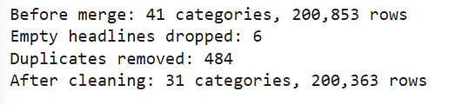
Figure 5. Description of the HuffPost dataset following data cleaning
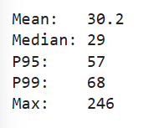
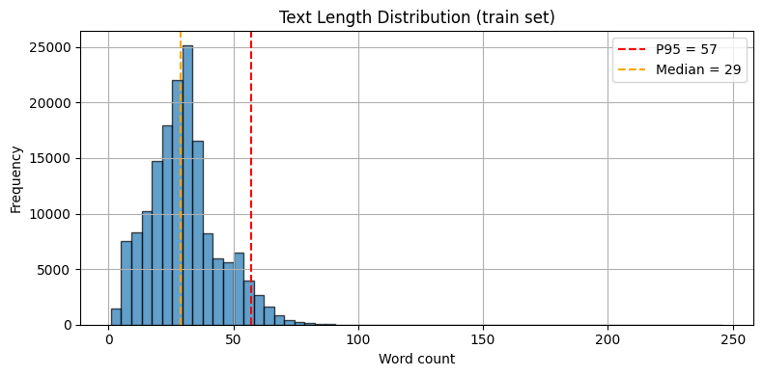
Figure 6. Bar chart of text length distribution of the HuffPost dataset
Figure 7. Statistics for the text distribution of the HuffPost dataset

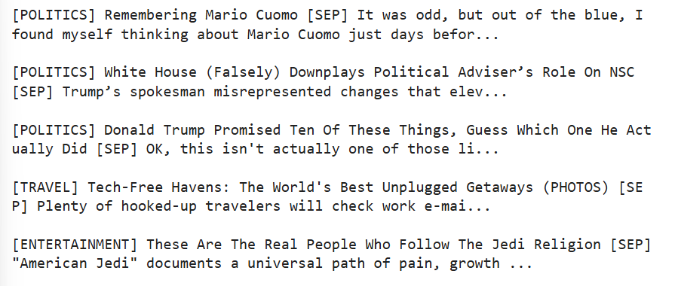
Figure 8. Sample examples from the HuffPost dataset following cleaning

Appendix B - Class by Class evaluation metrics

Table 2. DistilBERT Classification Report (Test Set)
Class | Precision | Recall | F1-Score | Support
ARTS | 0.6045 | 0.6263 | 0.6152 | 388
BLACK VOICES | 0.4749 | 0.4592 | 0.4669 | 453
BUSINESS | 0.5808 | 0.5387 | 0.559 | 594
COMEDY | 0.5366 | 0.4391 | 0.483 | 517
CRIME | 0.6136 | 0.6353 | 0.6243 | 340
DIVORCE | 0.8043 | 0.7573 | 0.7801 | 342
EDUCATION | 0.5446 | 0.5674 | 0.5558 | 215
ENTERTAINMENT | 0.7101 | 0.764 | 0.7361 | 1606
ENVIRONMENT | 0.6 | 0.6015 | 0.6008 | 394
FIFTY | 0.3889 | 0.25 | 0.3043 | 140
FOOD & DRINK | 0.7873 | 0.8762 | 0.8294 | 832
GOOD NEWS | 0.449 | 0.3165 | 0.3713 | 139
HOME & LIVING | 0.6739 | 0.5714 | 0.6185 | 1085
IMPACT | 0.4939 | 0.3536 | 0.4122 | 345
LATINO VOICES | 0.5 | 0.4867 | 0.4933 | 113
MEDIA | 0.5768 | 0.548 | 0.562 | 281
MONEY | 0.5625 | 0.5294 | 0.5455 | 170
PARENTING | 0.734 | 0.7697 | 0.7515 | 1255
POLITICS | 0.8057 | 0.801 | 0.8034 | 3272
QUEER VOICES | 0.8288 | 0.683 | 0.7489 | 631
RELIGION | 0.5876 | 0.6732 | 0.6275 | 254
SCIENCE | 0.6683 | 0.6284 | 0.6478 | 218
SPORTS | 0.7557 | 0.7464 | 0.751 | 489
STYLE | 0.792 | 0.8707 | 0.8295 | 1176
TECH | 0.5045 | 0.5517 | 0.5271 | 203
TRAVEL | 0.8278 | 0.8311 | 0.8295 | 989
WEDDINGS | 0.8048 | 0.8247 | 0.8146 | 365
WEIRD NEWS | 0.4955 | 0.412 | 0.4499 | 267
WELLNESS | 0.6968 | 0.8187 | 0.7528 | 1782
WOMEN | 0.4186 | 0.3706 | 0.3931 | 340
WORLD NEWS | 0.7674 | 0.7447 | 0.7559 | 842

